2019 CALENDAR ORDER FORM
We are pleased to offer the Anglican Church Calendar for 2019.

This year’s theme features the “inside and outside” of cathedrals across the country, showing what happens both inside and outside the Church as well as the physical inside and outside of Anglican cathedrals.

The funds raised will assist the Anglican Church Women to continue with their many outreach programs. We appreciate your help with these commitments.

Make cheques payable to the ACW Diocese of New Westminster, noting your parish name on the cheque.

Name of Parish______________________________________________
Name of Contact Person______________________________________
Phone #____________________ email___________________________

Number of calendars ordered_______ x Cost $6.00 each = $_________
PLEASE have order and payment in before July 31, 2018 to
ACW Calendar Secretary, c/o ACW Place, Unit B, 7012 Merritt Avenue, Burnaby B. C. V5J 4R6
Orders can be mailed with the payment or emailed to the Calendar Secretary:
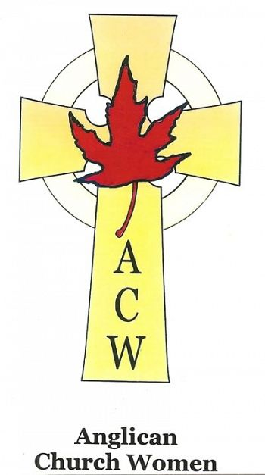
Sylvia Enga at landseer_7@uniserve.com

Many thanks for your support.
Anglican Church Women
Diocese of New Westminster

