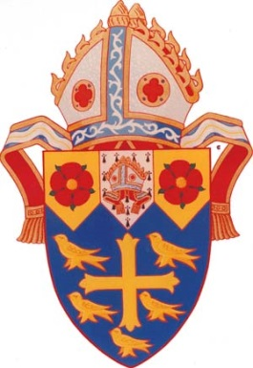

A Message from the Bishop: Praying for Those Affected by Internment and the Protection of Civil Liberties on Sunday, February 19th
In the USA, President Roosevelt signed Executive Order 9066 on February 19, 1942. Five days later, on February 24, 1942, Prime Minister King signed Order-in-Council P.C. #1486. Both of them empowered the Minister of Justice to control the internment of all persons of Japanese origin. What this means is that this year is the 75th anniversary of the US and Canada making the decision to remove people of Japanese heritage from their homes and businesses and send them to internment camps.
Accordingly, I ask that on Sunday, February 19th you include prayers for those in the US and in Canada of Japanese heritage who were harmed by these orders of internment as well as for the protection of civil liberties in our country. The following prayer or a version of it from The Book of Alternative Services may be appropriate.
Almighty God, you have given us this good land as our heritage. May we prove ourselves a people mindful of your generosity and glad to do your will. Bless our land with honest industry, truthful education, and an honourable way of life. Save us from violence, discord, and confusion; from pride and arrogance; and from every evil course of action. Make us who came from many nations with many different languages a united people. Defend our liberties and give those whom we have entrusted with the authority of government the spirit of wisdom, that there may be justice and peace in our land. When times are prosperous, let our hearts be thankful; and, in troubled times, do not let our trust in you fail. We ask this through Jesus Christ our Lord.

