**Solar Suitcases** – Medical staff at 28 rural health centres in 9 districts of Nampula province in Mozambique now have a reason to celebrate sunnier days.  In July, PWRDF’s partner EHALE hosted a training for 11 technicians to learn how to install, operate and maintain solar suitcases. After two days of in-classroom training, the trainees were accompanied in the field by the two solar suitcase trainers from California; Dr. Brad Holden and Ms. Whitney Owen to practice what they learned. Two PWRDF staff also accompanied this training.

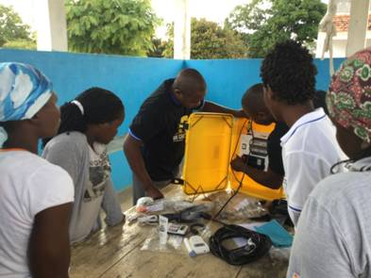

Solar suitcases provide power that is portable, economical and easy-to-use. We Care Solar recently won the inaugural, United Nations DESA award for the “sustainable future we want” because of these solar suitcases. The electricity the solar suitcases provide empower health workers to save lives. The lighting is of the standard required for surgeries and medical procedures. The Solar Suitcases were designed to support timely and efficient emergency obstetric care, but can also be used in a range of medical and humanitarian settings. For clinic installations, the yellow case becomes a cabinet that mounts to a wall, while the solar panel is fastened to a roof to harvest sunlight and to convert it into electricity. The system provides high-efficiency LED medical task lighting, a universal cell phone charger, a battery charger for AAA or AA batteries, and outlets for 12V DC devices. The basic system comes with 80 watt of solar panels, and a 12 amp-hour lithium ferrous phosphate battery. The maternity kit also comes with a fetal Doppler that is used to monitor the heart rate of a fetus in utero.

After the installation of solar suitcases, nurses were trained on how to operate them. and able to teach others. There was a high level of enthusiasm throughout the training and installation phases. Trainees were challenged to exit their comfort zones. Vitorina for example, who is a veteran nurse that works with EHALE, mounted a solar suitcase despite never having touched a power drill in her life. By the end of the 10-day training, Vitorina emerged as one of the best trainees.  Nurses from the rural clinics told the group about the difficult conditions under which they were operating.  Nurse Latia Virgilio from Namahaca Health Centre explained that during the month of June, she delivered 184 babies and two thirds of them during the night.  Prior to the installation of solar suitcases, it was common for Latia to deliver babies with only the light of her cellphone, held in her mouth so as to have two hands free for the delivery. One night she delivered 8 babies in a row.  During the month of August she delivered 203 babies. Latia thought women in labour might be more willing to come to the clinic to deliver their babies assisted by a trained health professional, now that the health centre has electricity. Already it is interesting to note that the health centres that now have solar suitcases reported an increase in deliveries at night.  Nurse Eusebio Mario from Muaualo Health Centre explained that he now stay longer at the health centre because the light allows him to do his paper work after each delivery.  In the past, paperwork could only be done the following day.

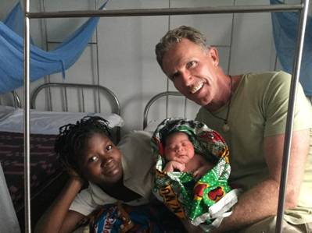

While training the Mozambican crew on how to install and operate a solar suitcase in Muaualo Health Centre, Dr. Brad Holden, a pediatrician doctor used his medical skills and his ambu bag to resuscitate a baby that was born asphyxiated with weak vital signs. The quick intervention of Dr. Brad Holden was so much appreciated by the mother and grandmother that they named the little baby boy “Brad.” Having noted that local nurses do not have much experience using a ambu bag, Dr. Brad decided to take the time to train every nurse how to properly use the ambu bag at every clinic were a solar suitcase was installed.