About the We Care Solar Suitcase®
The basic We Care Solar Suitcase® is a complete systems that includes two 20 watt solar panels, a 14 amp-hour sealed lead acid battery, a 15A charge controller, two headlamps, a phone charger, a AA/AAA battery charger, and a fetal Doppler. Hardware for installation is included, along with a users manual and users poster.

Our award-winning We Care Solar Suitcase® is an economical, easy-to-use portable power unit that provides health workers with highly efficient medical lighting and power for mobile communication, laptop computers and small medical devices. The We Care Solar Suitcase was originally designed to support timely and efficient emergency obstetric care, but can be used in a range of medical and humanitarian settings. For clinic installations, the yellow case becomes a cabinet that mounts to the wall, and the panels are secured to the roof.

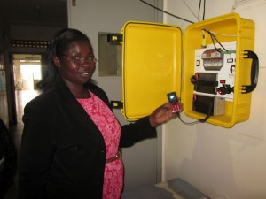

The system includes high-efficiency LED medical task lighting, a universal cell phone charger, a battery charger for AAA or AA batteries, and outlets for 12V DC devices. The basic system comes with 40 or 80 watts of solar panels, and a 12 amp-hour lithium ferrous phosphate battery. The maternity kit comes with a fetal doppler.

Whole System Integration – The lighting appliances and power production components are delivered as one unit, designed for daily use.

Safety – The sealed batteries can safely be stored inside health facilities; the low-voltage DC system avoids shock hazard and includes overcurrent protection.

Low Maintenance – There are no fuses to replace, and no regular battery maintenance is required. Battery replacement is estimated to occur every 2 years.
Durability – Our high quality components are designed for longevity, even in harsh environments.
Simplicity – One switch turns on the system; another turns on lights and charges devices. The system is plug-and-play and can be installed without need for an experienced solar technician.
Expandability – The 15 amp modular system is designed for expansion and can accommodate up to 200 watts of solar panels and a 100 amp-hour sealed battery.

An expansion kit is available for utilizing larger batteries and additional lights.
Two versions of the expanded Solar Suitcase are shown here.

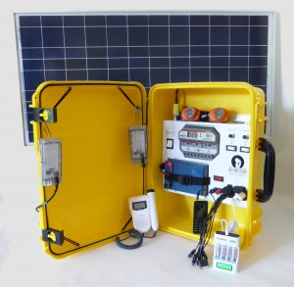

This We Care Solar Suitcase includes a 65 watt glass-aluminum panel, as well as two LED medical lights, two headlamps, a phone charger, AA and AAA battery charger, and a fetal Doppler. It includes the hardware for mounting the solar panel and attaching the yellow case to the wall.

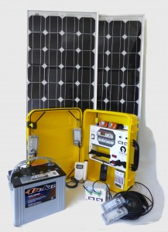

This expanded system has two 80-watt panels, a 79 Ah sealed AGM battery, and an extra set of LED medical lights. In addition to charging phones, headlamps and a fetal doppler, it can charge a laptop computer and other devices.

